#include<iostream>
using namespace std;
#include <string>

class TStudent {
static float m_ClassMoney;
string m_name;
int i;
public:
void InitStudent(const char name[])
{
m_name = name;

};
void ExpendMoney(float money)
{

m_ClassMoney = m_ClassMoney - money;
};
void ShowMoney()
{
cout << "班费还剩余" << m_ClassMoney << endl;
};
};
float TStudent::m_ClassMoney = 1000;

int main()
{

TStudent name[3];
name[1].InitStudent("a ");
name[1].ExpendMoney(50);
name[1].ShowMoney();
name[2].InitStudent(" b");
name[2].ExpendMoney(98.5);
name[2].ShowMoney();
}
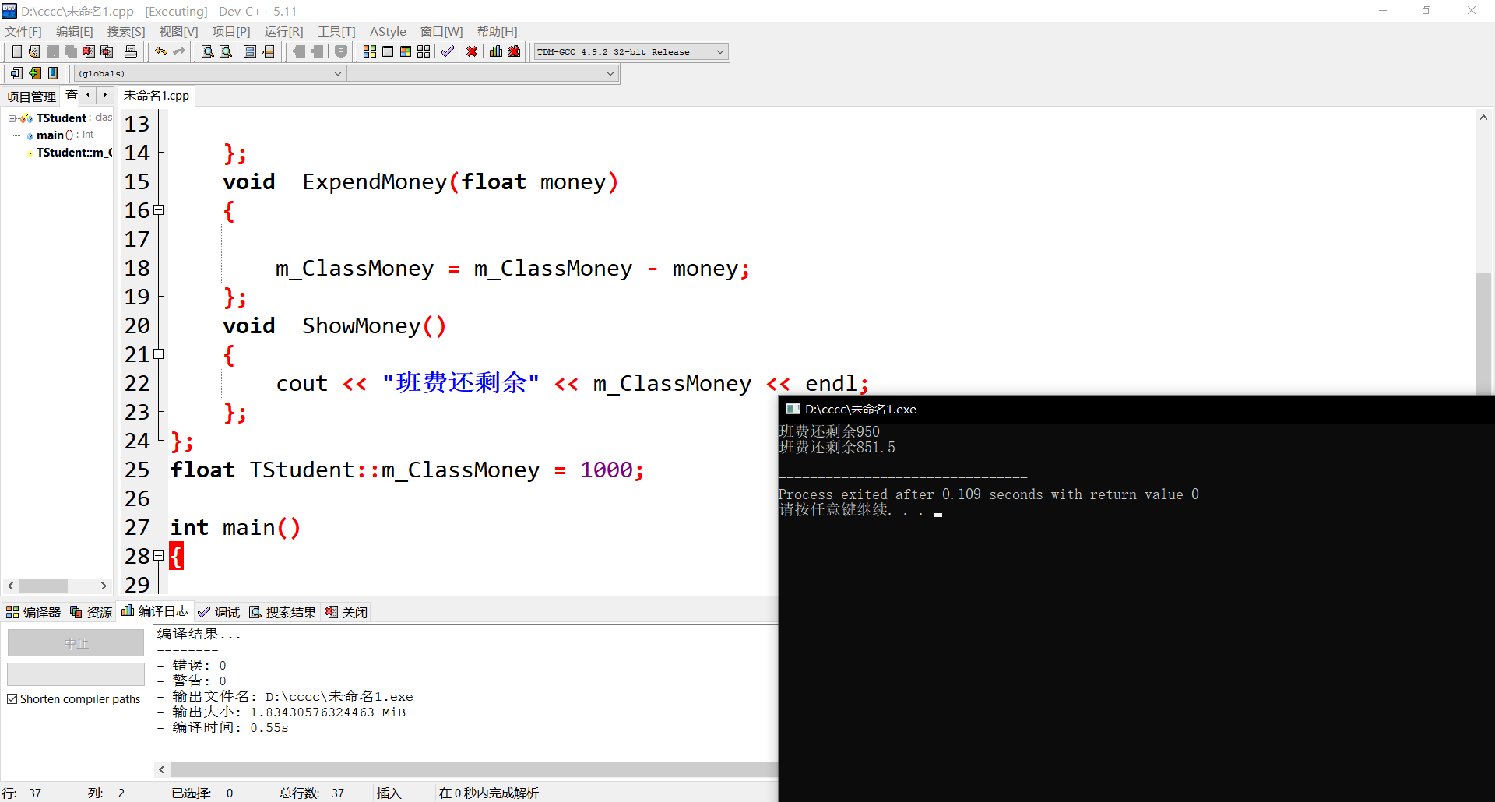
感想：我对C++的精力投入真是少之又少，整日被学生会和新媒体组织的琐事缠身，虽然在其他技术方面有很大收获，但是C++知识没有彻底巩固和落实。

